Cloud Computing
CAT-2 Project

KISHORE.S – 1934019
NAREAN KARTHIK P – 1934024
SREEKANTH S – 1934046

Problem Statement:

The motive it to play music player efficiently and with some of the functions efficiently so that the music webpage were created with some front end design through that music and some images respectively.

Problem Solution:

Our attempt to move this music player for some users who likes and it used to travel long with the help of Docker container and Kubernets.

DOCKER FILE:

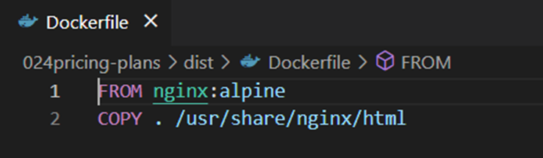

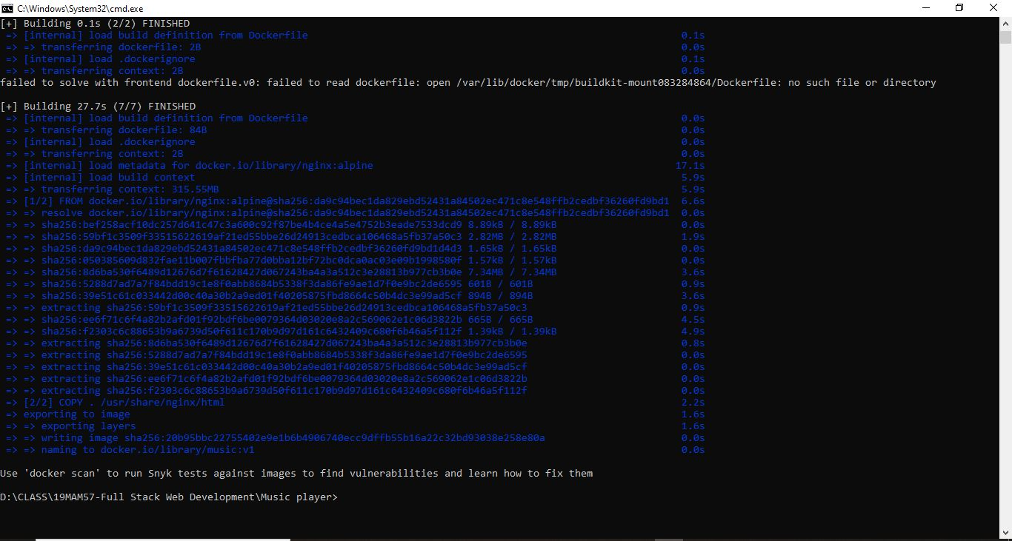
BUILDING DOCKER IMAGE:

RUNNING TIME:

IMAGE CACHING:

LAYER CACHING:

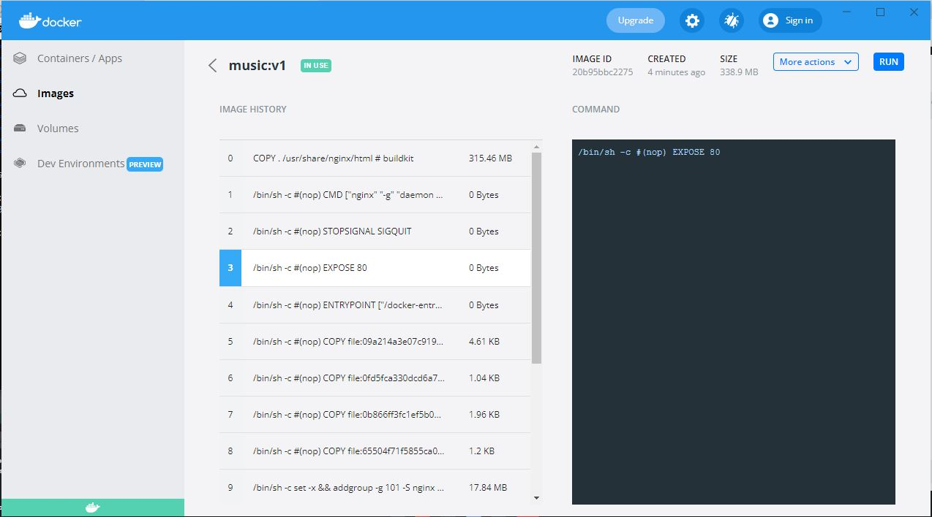

CONTAINER:

CONTAINER SERVICE EXPOSURE:

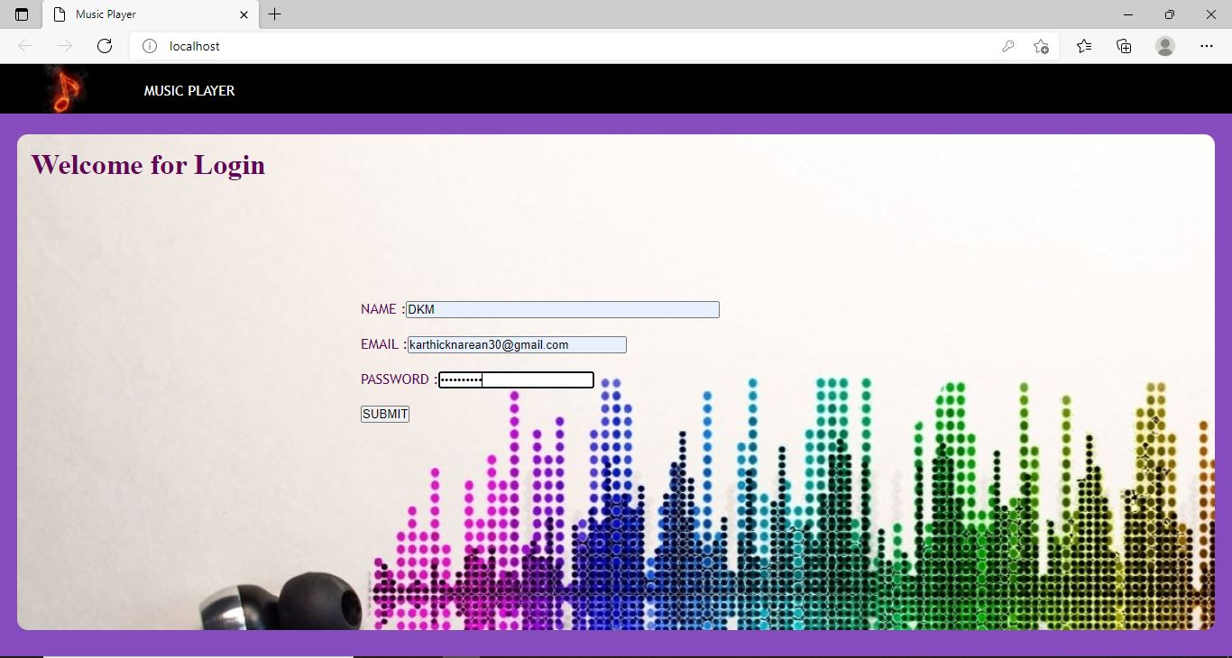

DOCKER LOGS:

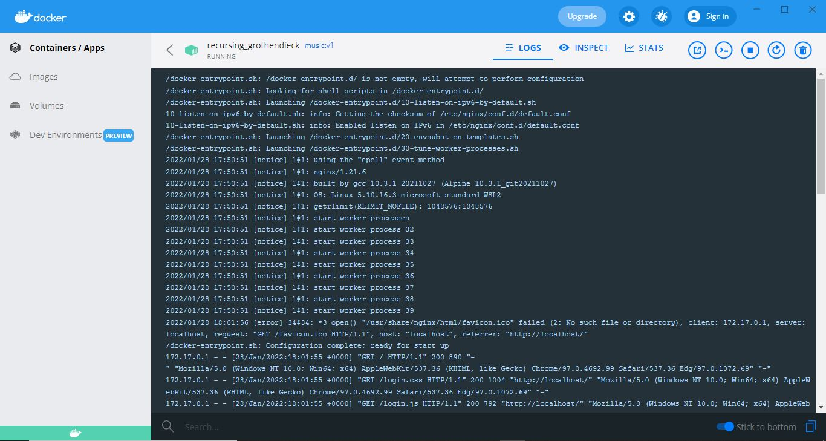

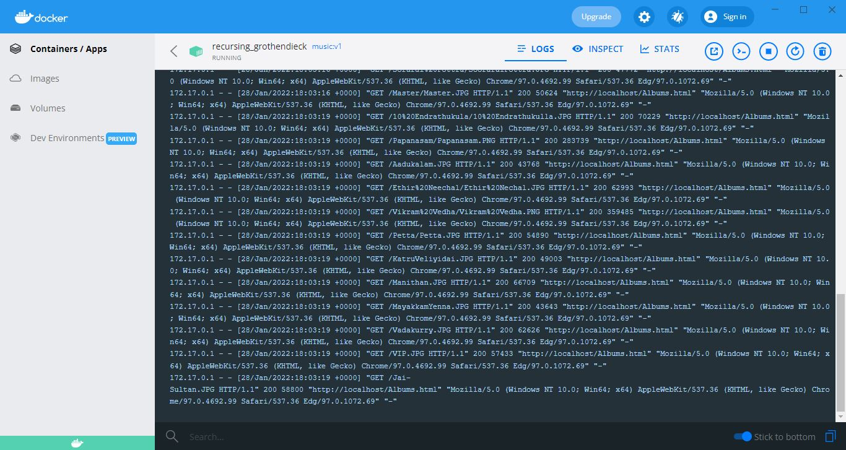

EXECUTING INTO THE CONTAINER:

KUBERNETS:

STARTING MINI-CUBE:

CREATING NAMESPACE:

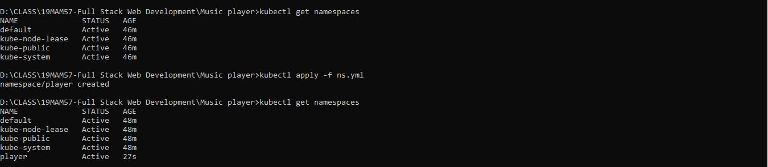

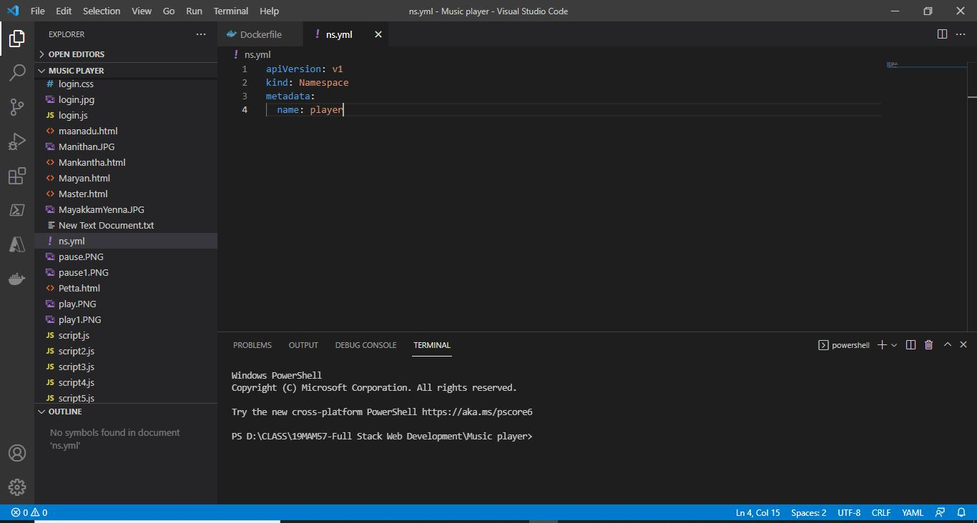

CREATING POD:

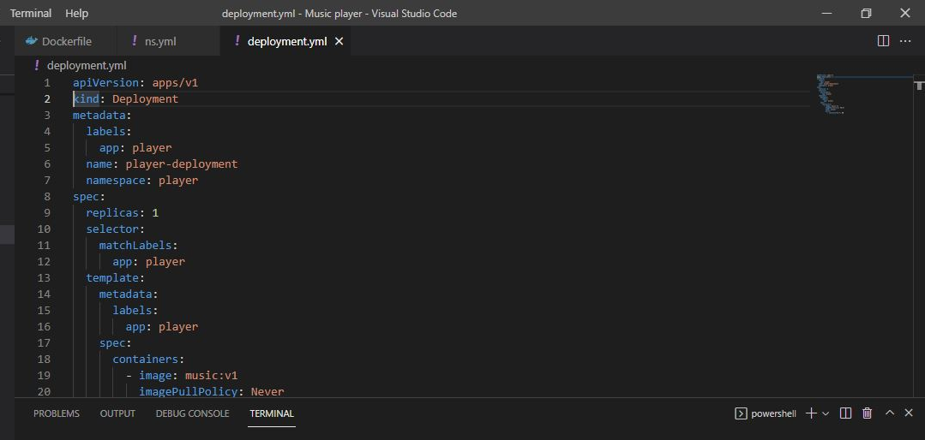

POD DEPLOYMENT:

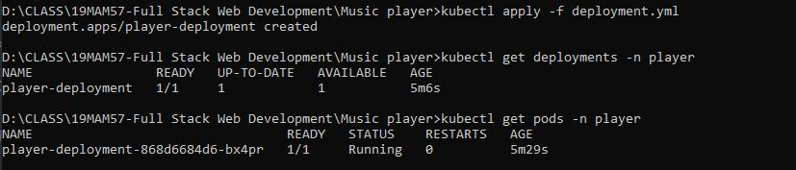

CONFIGURING DEPLOY POD WITH 2 REPLICAS:

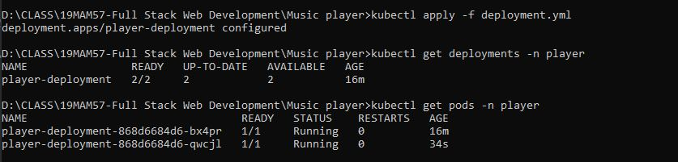

SERVICE EXPOSURE:

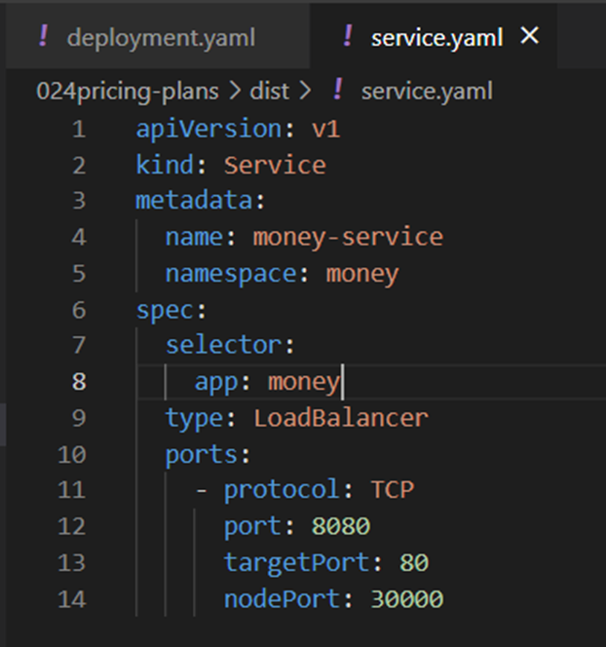

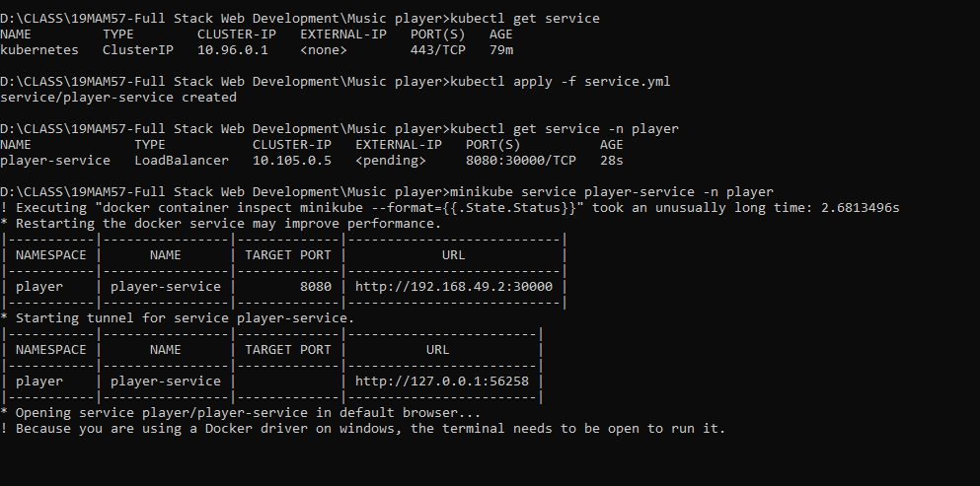
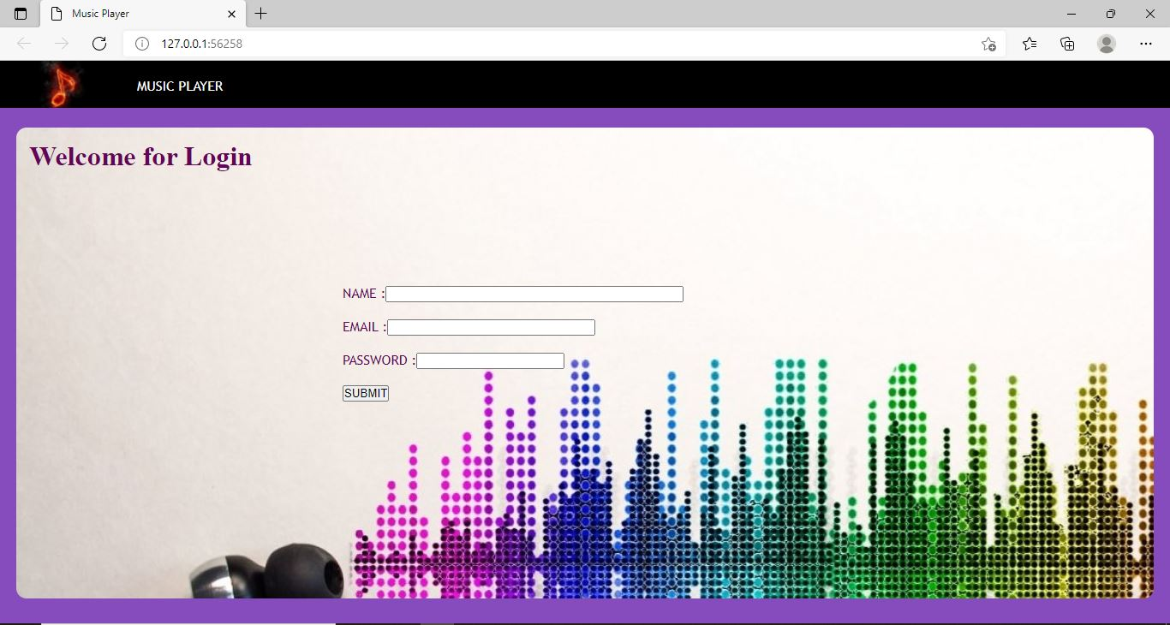
HOSTED WEBPAGE:

RESOURCE LIMITATION:

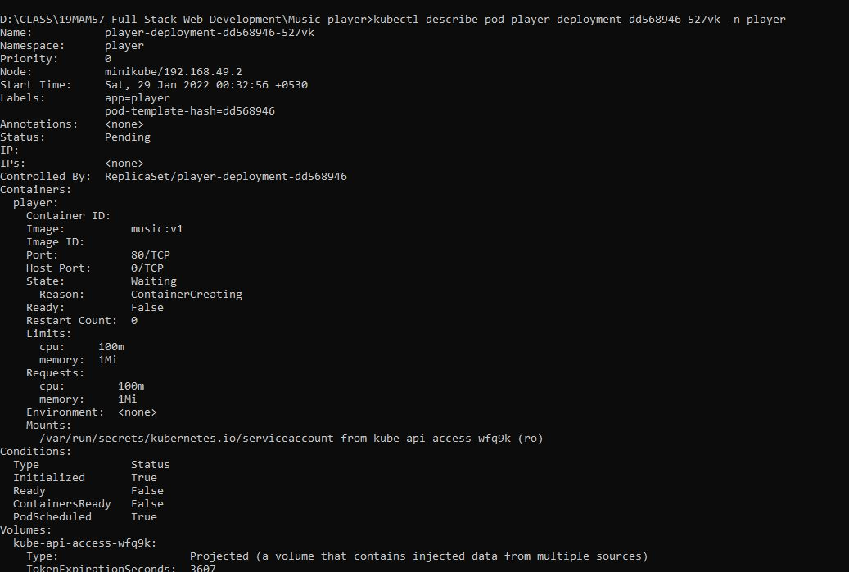

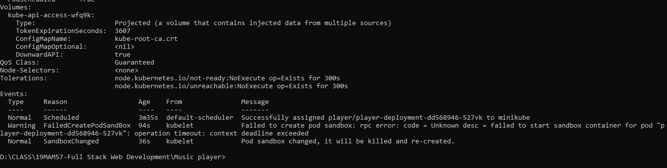
ROLLBACK STRATEGY:

VERSION-01

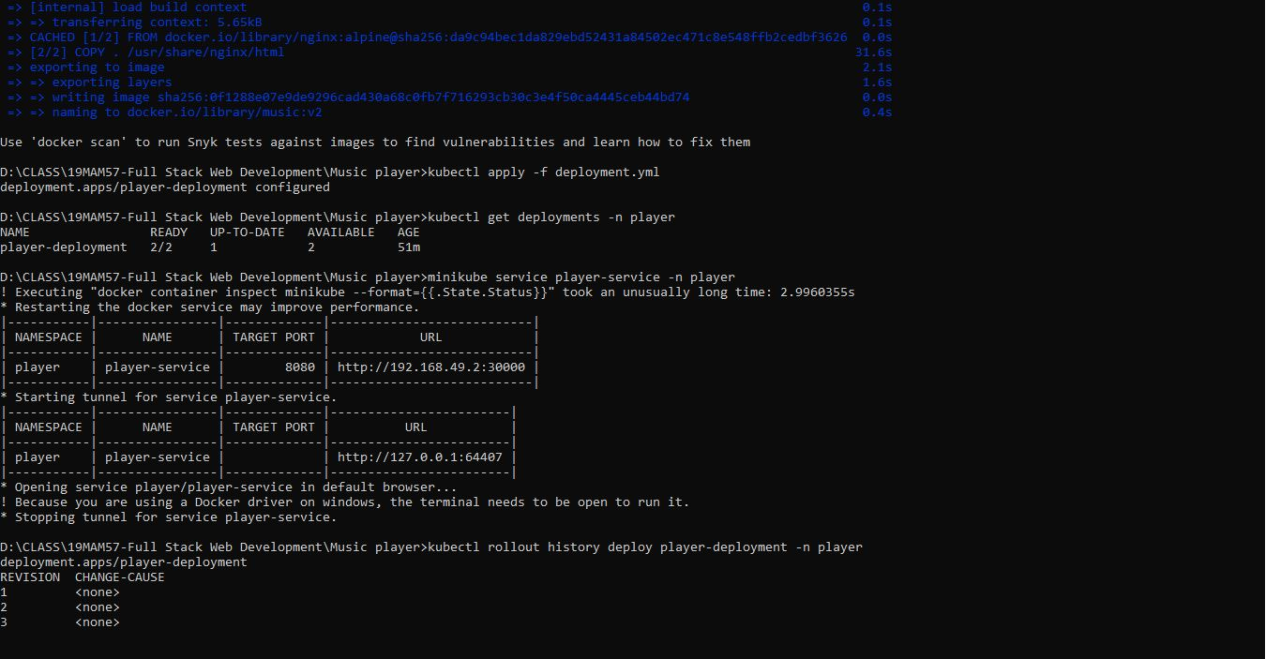

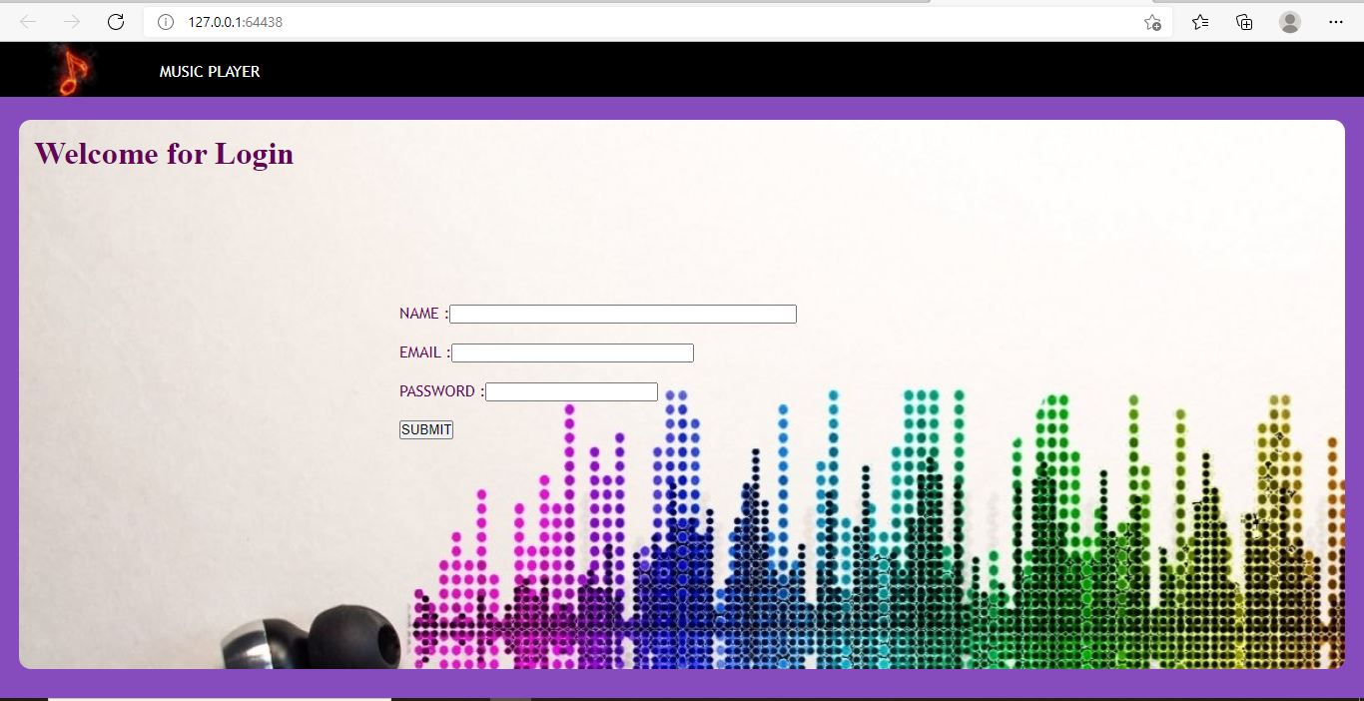
VERSION-02

